KKAS -

Functionality
The WIP calculation function valuates the unfinished products (work in process).
In the Product Cost by Period component, work in process is valuated at target costs. The operation quantities confirmed for the manufacturing orders or production versions (only in repetitive manufacturing) that are not scrap are valuated at target cost in accordance with the valuation variant for work in process and scrap.
You calculate work in process at target costs for the following objects:
- Product cost collectors
- Production orders with quantity structure assigned to the product cost collectors
- Process orders assigned to the product cost collectors

Scenario
As part of the period end processing Work In Process needs to be calculated prior to variance calculation and settlement for accurate period end closing.

Requirements

Overhead surcharges need to have been calculated

Menu Path | Accounting → Controlling → Product Cost Controlling → Cost Object Controlling → Product Cost by Period → Period-End Closing → Single Functions: Product Cost Collector → Work in Process → Individual Processing → KKAS - Calculate
Transaction Code | KKAS

1. Double click on KKAS - Calculate

Calculate Work in Process: Individual Processing

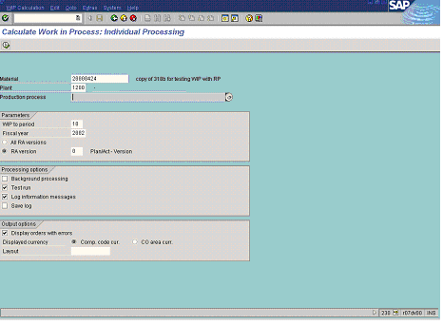

2. Update the following fields:

Field Name | Field Description | Values
Material | Code identifying a product or component. | Example: 20000424
Plant | Code identifying the operational unit of the company where the material is manufactured and stored | Example: 1200
Settlement period | Number identifying a fiscal month relevant for posting. | Example: 10
Fiscal year | The Fiscal year of settlement | Example: 2002

3. Press [F4] or click the Search button in the Production process field.
Choose production processes for material/plant

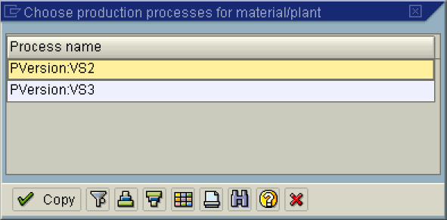

4. Double click on the PVersion:VS2 in list box.

Calculate Work in Process: Individual Processing

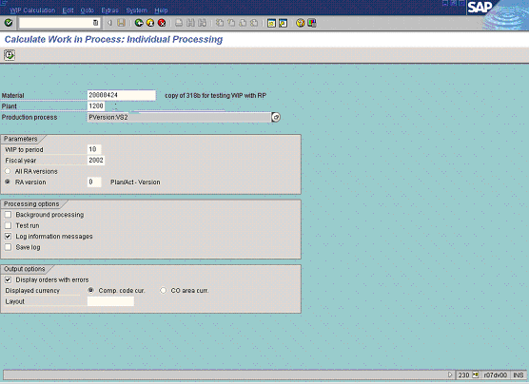

5. Click the All RA versions radio button.
6. Click the Test run checkbox to deselect.
7. Click the Execute button.

Calculate Work in Process: Object List

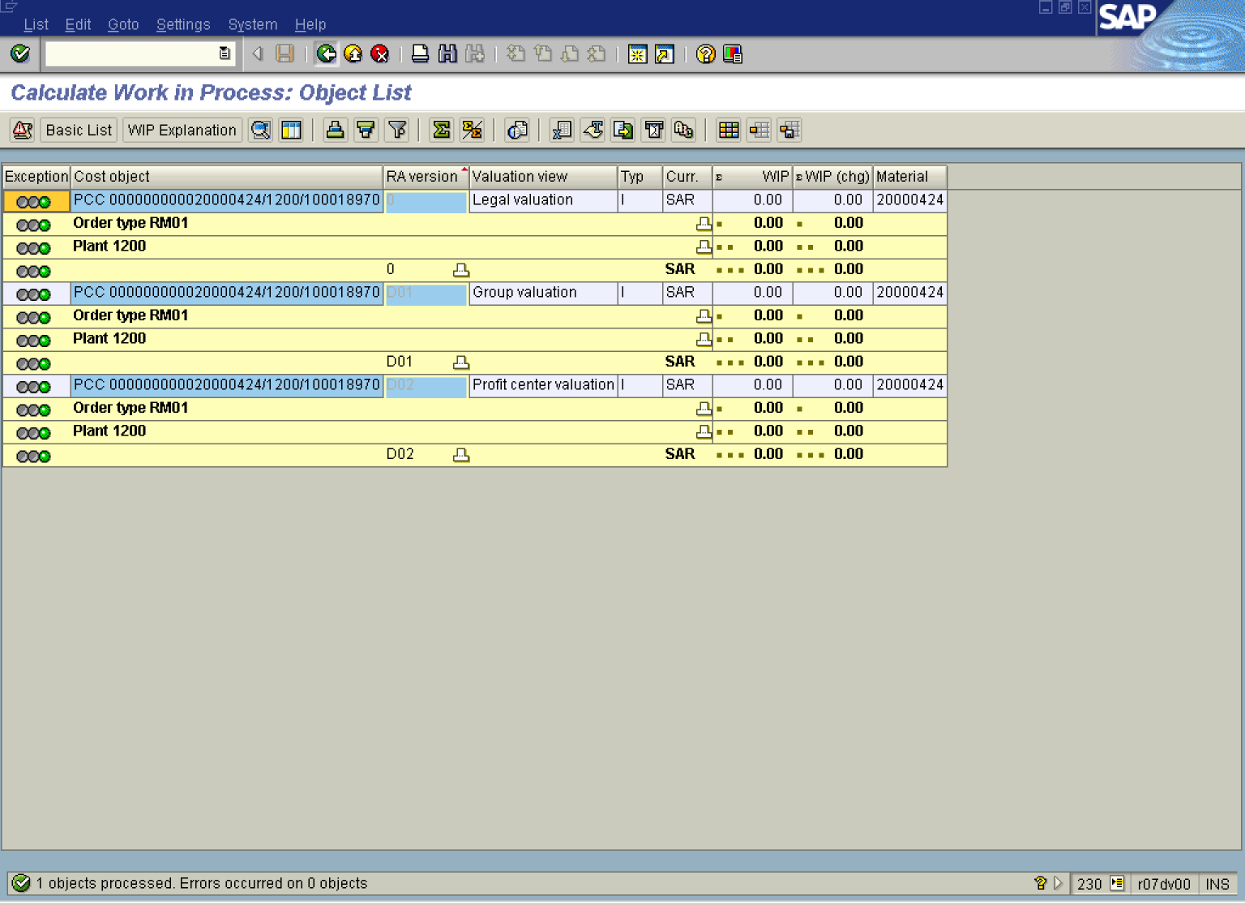

Note: For Repetitive Manufacturing, Error Msg 'No WIP because no Reporting Point' is generated. Ignore this because there is no WIP in repetitive manufacturing.

8. Click the Back button.

Exit list

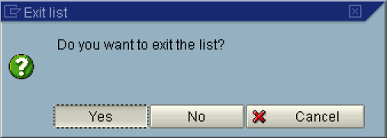

9. Click the Yes button.

